**CAPSTONE PROJECT REPORT**

(Project Term August-December 2021)

## Indian Sign Language Interpreter for Hearing Impaired Persons

Submitted by

|  |  |
| --- | --- |
| **Arun Singh** | **11804263** |
| **Dora Praveen Kumar** | **11810758** |
| **Kelothu Shivaprasad** | **11804573** |

**Project Group Number CSERGC0175**

**Course Code CSE439**

Under the Guidance of

**Ankita Wadhawan**

# School of Computer Science and Engineering



## PAC Form

## 

## DECLARATION

We hereby declare that the project work entitled **Indian Sign Language Interpreter for Hearing Impaired Persons** is an authentic record of our own work carried out as requirements of Capstone Project for the award of B. Tech degree in Computer Science from Lovely Professional University, Phagwara, under the guidance of (Name of Faculty Mentor), during August to November 2020. All the data labeled in this capstone project report is based on our own hard work, research and truly real.

Project Group Number: **CSERGC0175**

|  |  |
| --- | --- |
| **Arun Singh** | **11804263** |
| **Dora Praveen Kumar** | **11810758** |
| **Kelothu Shivaprasad** | **11804573** |

Name of Student 1: **Arun Singh**

Registration Number: **11804263**

Name of Student 2: **Dora Praveen Kumar**

Registration Number: **11810758**

Name of Student 3: **Kelothu Shiva Prasad**

Registration Number: **11804573**

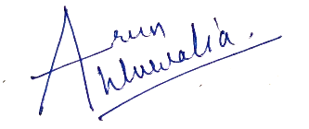

Date: 10-12-2021

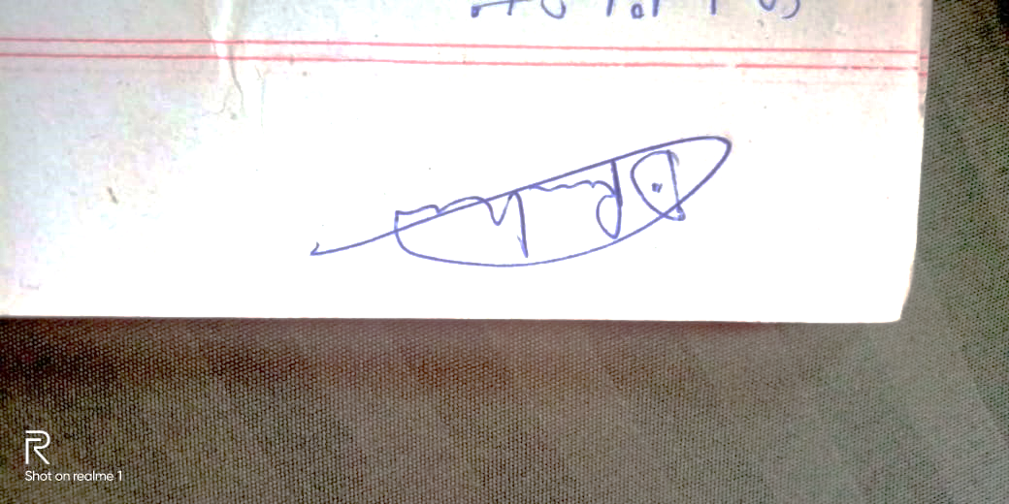

Date: 10-12-2021

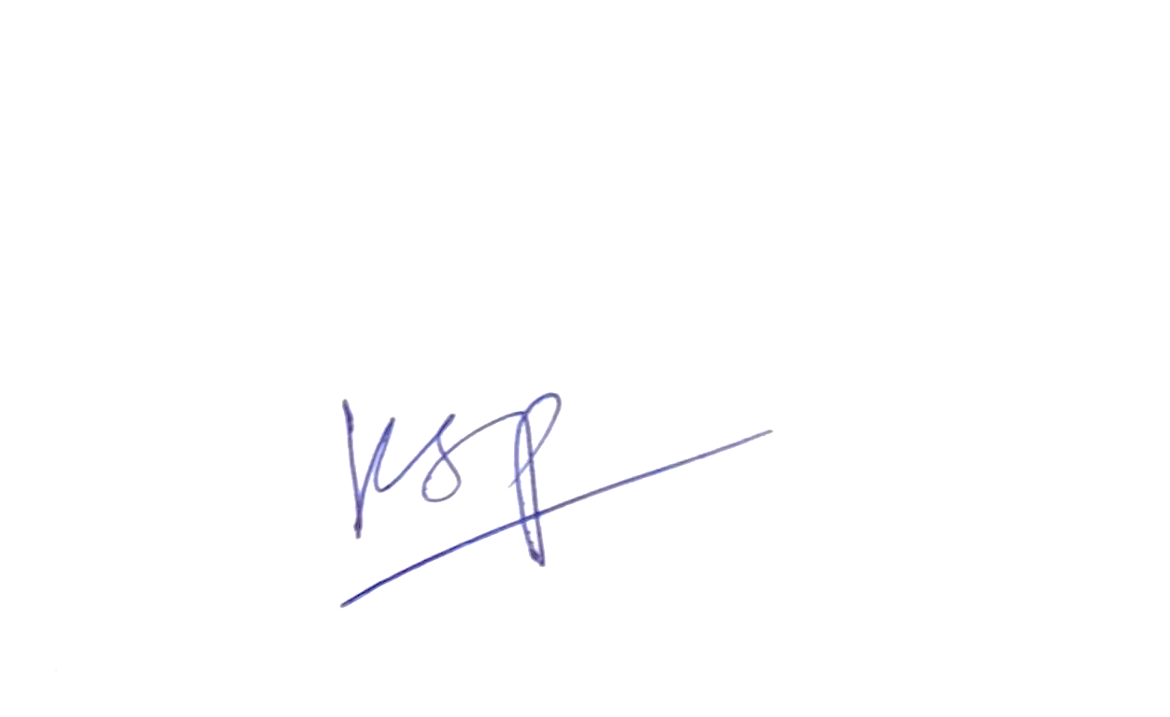

Date: 10-12-2021

**CERTIFICATE**

This is to certify that the declaration statement made by this group of students is correct to the best of my knowledge and belief. They have completed this Capstone Project under my guidance and supervision. The present work is the result of their original investigation, effort and study. No part of the work has ever been submitted for any other degree at any University. The Capstone Project is fit for the submission and partial fulfillment of the conditions for the award of B.Tech degree in Computer Science and Engineering from Lovely Professional University, Phagwara.



**Signature and Name of the Mentor**

**Ankita Wadhawan**

**Assistant Professor**

**School of Computer Science and Engineering,**

Lovely Professional University,

Phagwara, Punjab.

Date : 10-12-2021

**ACKNOWLEDGEMENT**

We would like to express our gratitude and appreciation to all those who gave us the possibility to complete this project. Special thanks to our supervisor and mentor **Ms. Ankita Wadhawan** for her co-operation and guidance which helped us in completion of this project.

We would also like to thank School of Computer Science and Engineering for assigning us the task of this capstone project and accepting our idea about the project.

THANKING YOU

**Arun Singh 11804263**

**Dora Praveen Kumar 11810758**

**Kelothu Shiva Prasad 11804573**

**TABLE OF CONTENTS**

Inner first page…...………………………………………………………………….(i)

PAC form…...………………………………………………………………………(ii)

Declaration…..……………………………………………………………………...(iii)

Certificate……..…….………………………………………………………………(iv)

Acknowledgement…………………...………………………………………….......(v)

Table of Contents……………………...……………………………………………(vi)

**1. INTRODUCTION 1**

## 2. PROBLEM STATEMENT 2

**3. EXISTING SYSTEM 3**

**3.1 INTORDUCTION 3**

* 1. **EXISTING SOFTWARE 3**
  2. **DIFFERENCE IN OUR SYSTEM 3**

**4. PROBLEM ANALYSIS 4**

**4.1 OBJECTIVES 4**

**4.2 SCOPE 4**

**5. SOFTWARE REQUIREMENT ANALYSIS 5**

* 1. **USER PROFILR 5**
  2. **ASSUMPTIONS 5**
  3. **FUNCTIONAL & NON-FUNCTIONAL REQUIREMENTS 5**

**6. DESIGN 6-7**

**7. IMPLEMENTATION 8**

**8. TESTING 9**

**9. SOURCECODE & SYSTEM SNAPSHOTS 10-20**

**10. CONCLUSION 20**

**11. BIBLIOGRAPHY 21**

1. **INTRODUCTION**

## The project we have chosen is to help the hearing and speech impaired people by creating a deep-learning based Sign Language Interpreter which would help in communicating their language to us in a more efficient and comfortable way. The work comprises of collecting video dataset from more than 12 people and for 50 signs we would be building a model and training it and making it learn the signs we have collected all the signs are dynamic and not static which makes our work even more unique and practical. We would be dividing the video into frames and using different CNN layers optimizers and activators to extract features from the video as model training is not possible directly on the videos itself. Then we deploy our model on the cloud and make a web app/ mobile app so that everyone can use it.

## Basic Objectives:

## Collecting data of dynamic videos

## Developing a model

## Training the model

## Testing and predicting

## A web/ mobile based sign language interpreter

# 2. PROBLEM STATEMENT

In the world roughly 15-20% of the population is suffering from hearing or speech impairment and in India the World Health Organization says 2.42 million people are suffering from it that’s a lot of people in the Indian society.

There is an unknown fact that there is not just a single sign language used across the globe but there are different sign languages in different parts of the country some even differ from state to state. The number of sign languages are more than 300 and counting till now.

The problems these people face is immense as there is no proper way for them to communicate in the public places, railway stations, etc. The only option most of them use is having to carry a translator with them which is obviously not fusible for all and are very expensive and would have to wait for them to arrive and have to adjust the timetable according to their arrival.

If you look for schools the number of schools and colleges available for them is mere negligible for the population they are and are located in far away places and not in every state of the country which makes them inaccessible to lead an independent life. The number of deaf and dumb schools in India are just 388 all in cities and none in the villages which it an even bigger problem.

The online resources available for them are mostly limited and irrelevant from what they are looking for but, one few online platform does exist which provides education to them is:

<https://indiansignlanguage.org/>

<http://www.islrtc.nic.in/> (Indian sign language research and training center)

There are just two resources available for them which is just not fair.

**3. EXISTING SYSTEMS**

**3.1 Introduction**

There are number of mobile applications and webapps available for ASL(American Sign Language) but when it comes to ISL (Indian Sign Language) there is only one available in the Indian market till now that is GnoSys.

**3.2 Existing Software**

**GnoSys:**

GnoSys is the only Indian Sign Language Interpreter available on web till now used across India. They are in collaboration with the NAD (National Deaf Association) for collection of sign and data for deploying the model.

This is an mobile application which make is accessible anywhere they want its inexpensive and offers high quality outputs making it the best and the only choice till now in the market.

They developers use Neural network with AI (Artificial Intelligence) and computer vision to record the signs the person is trying to say and then translates it and gives output as a audio so that everyone can understand.

**3.3 Difference in our Project**

Our method is to collect data of 50 dynamic signs from more than 12 and each sign will be performed 50 times which makes it 50x30x[]= 10,000 videos of dataset of even more.

Each sign having 200 videos. Then we would be making our own deep learning model and deploying it and would perform our training and testing on it to give us a good enough output as we desire it to be.

1. **PROBLEM ANALYSIS**

**4.1 Objectives**

1. Collection and development of dataset
2. Propose a model for sign language recognition system
3. Training the model
4. Testing the model
5. Creating a web/mobile based sign language interpreter

**4.2 Scope**

Currently in the market there is only one app dedicated to interpreting the Indian Sign language to the people around them. There are number of options available in other countries but that’s not the case here so we plan to make this project opensource so that students and all the tech enthusiasts can contribute to this work and make the lives of the needy more independent and self-centered

.  
In the recent times there are a number of research work done for which approach is best to deploy the models and what kind of models gives us what kind of accuracy. The best model could be picked up from there and the work could be expanded more making it give much better results when we have R&D done by researchers.  
  
Making this service free would be a stroke of luck in disguise for them and this would be first ever Indian Sign Language Interpreter app developed in India by Indian as the other services and applications available were developed in foreign soils.

**5. SOFTWARE REQUIREMENT ANALYSIS**

This project is developed on Google Collaboratory is which allows anyone to use it to deploy machine learning or deep learning model to train and test them for free of cost.

It allows python code to be run through the browser with out downloading any extensions or software’s on the system. It runs irrespective of your system configuration; the only thing required is a good internet connectivity and a browser to access it

**5.1 User Profile**

We are targeting people from 3 – 100< age group; it is not based on gender. The user needs to install our app or access the web application which will be available on Google Play Store or on the internet. After installing the app, the user can use the app. There is no need of logging in or signing up for the App or website. The user would express his/ her signs in the camera and it would be translation it into speech.

**5.2 Assumptions / Dependencies**

* Good internet connection
* Access to google collaboratory
* Access to play store/ website
* The code of model will be written in python
* The app will be written in XML and python.
* Deploying the model on a cloud server
* Linking of external websites is required for the app as different parts of the module works through the WebView method.

**5.3 Functional & Non-Functional Requirements**

* Active internet connection
* Knowledge of google colab
* Knowledge of deep learning
* Python GPU3 engine, 12GB RAM

# 6. DESIGN

**6.1 Collection and creation of dataset**

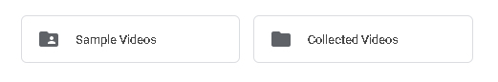

Fig.1. Sample videos and collected videos

**6.2 Segregating them into folders**

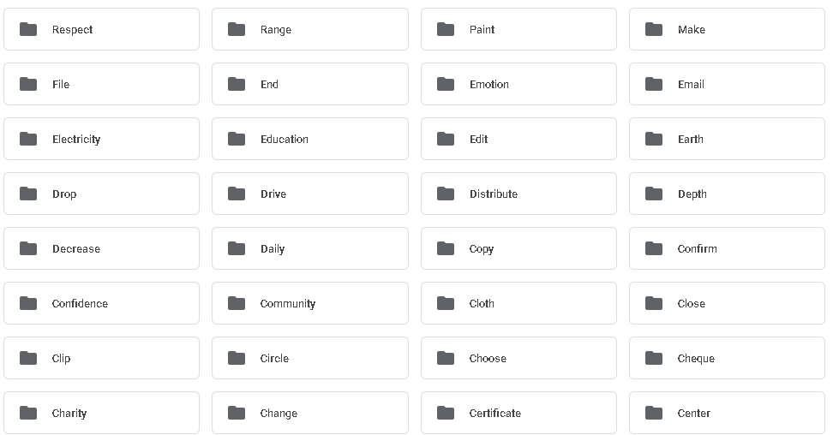

Fig.2.Dataset arranged into folders

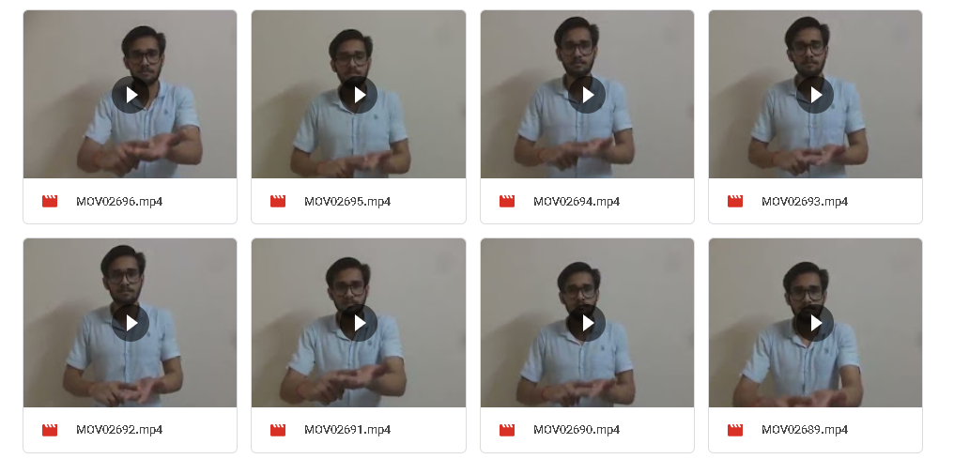

Fig.3. Folder contains files like this

**6.3 Creating our model**

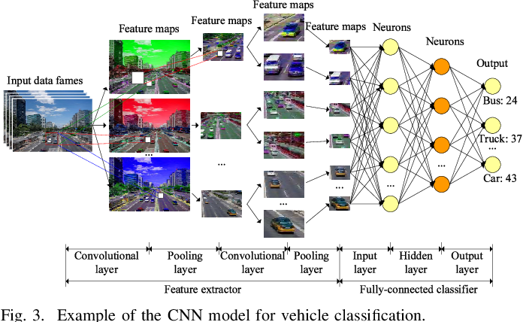

Fig.4. Example of model

**6.4 Training and Testing**

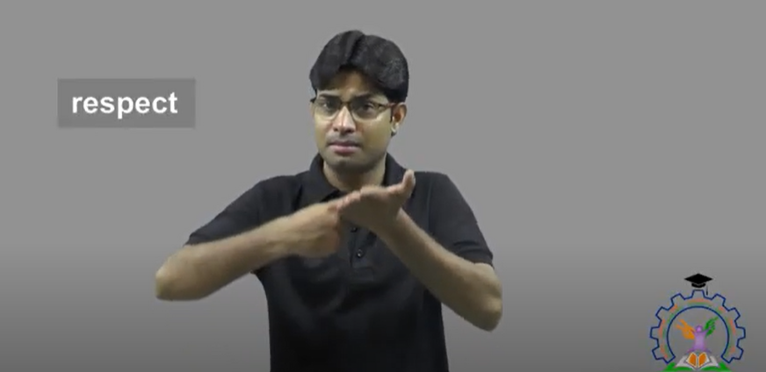

Fig.5. Testing sample

# 7. IMPLEMENATION

1. The dataset is collected from different people for 50 signs and each sign repeated for 30 times
2. Then the data is segregated into specific folders
3. Then the data is uploaded onto google drive to make it accessible to all.
4. Using Google colab
5. Loading the dataset
6. Listing the dataset
7. Importing libraries
8. Read and preprocess the list of class
9. Resizing and normalizing the dataset
10. Creating dataset
11. Splitting into training and test sets
12. Creating model
13. Training model
14. Getting model accuracy
15. Saving the model
16. Plotting the loss and accuracy curves
17. Making predictions

**8. TESTING.**

**8.1 Functional Testing**

Each module is tested multiple times using the google colab python3 GPU which gives us 12.69GB RAM and 107.72GB ROM but having an additional GPU and accelerator would boost the performance even more

**8.2 Structural Testing**

The internal structure has succeeded in producing expected outcome and has not exhibited any kind of glitch during manual structural testing.

**8.3 Levels of Testing**

Type of testing: Manual

1. Module-wise testing: Success

Testing outcome: Each module is individually tested for their functionality and performance and the testing completed with no glitches and bugs.

1. Integrated-module testing: Success

Testing outcome: All the modules are seamlessly working well with all the integrated modules with no glitches.

1. Model testing: Success

Testing outcome: A variation is seen every time the code is run on collab due to resources but if run on a physical hardware the code runs fine and gives the expected outcomes

**9. SOURCECODE AND SYSTEM SNAPSHOTS**

1. Loading the dataset
2. Listing the dataset

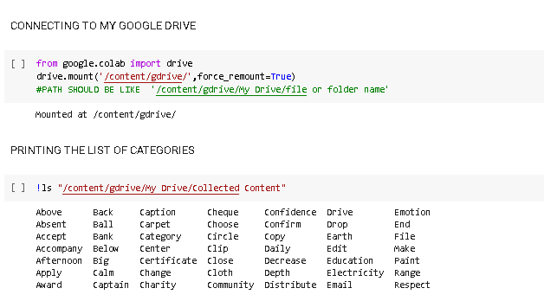

1. Importing libraries

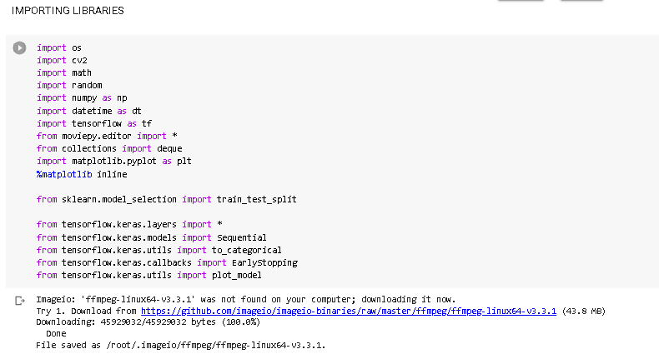

1. Setting seed

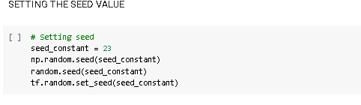

1. Creating grid of images with labels on top

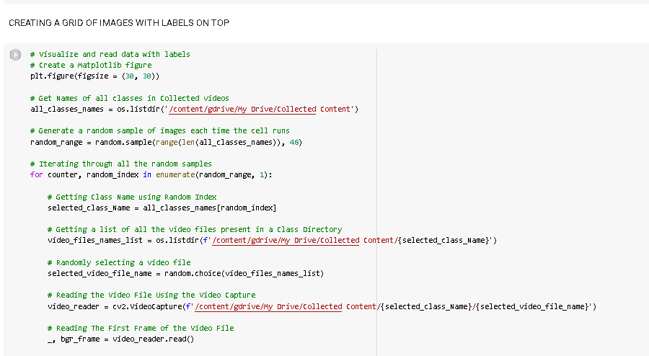

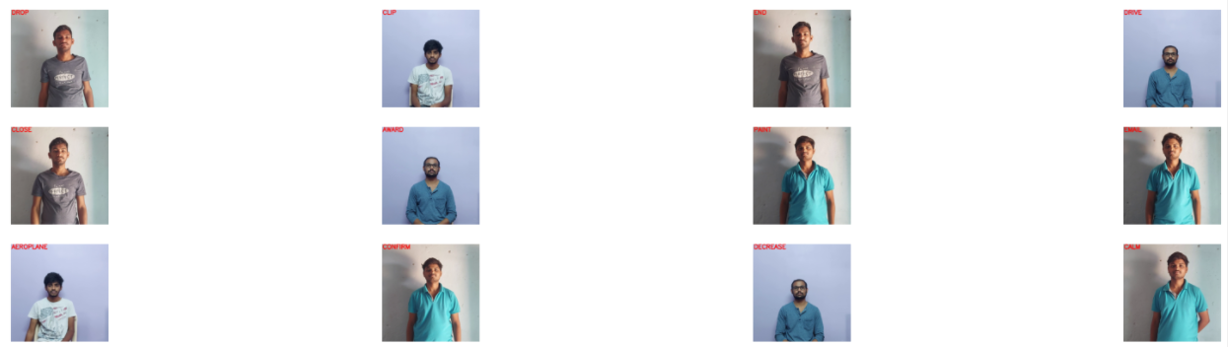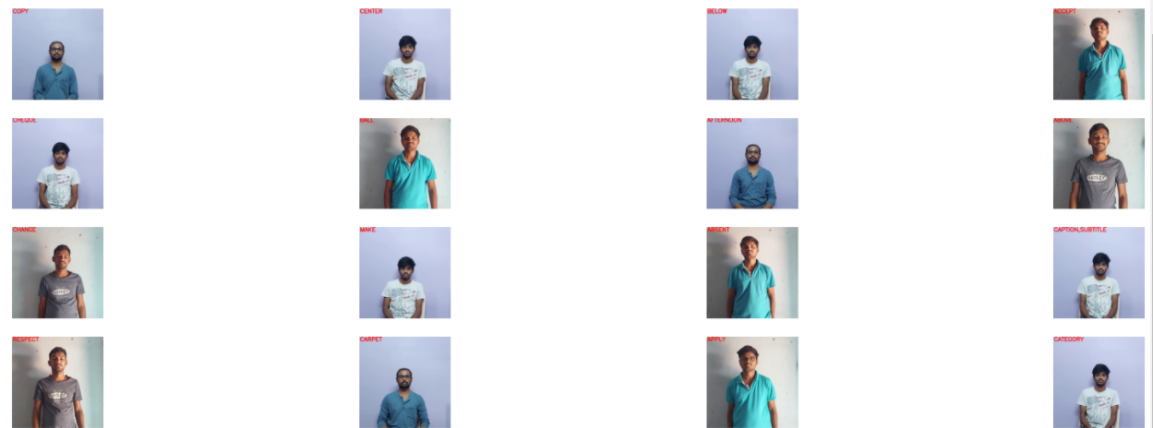

1. Read and preprocess the data

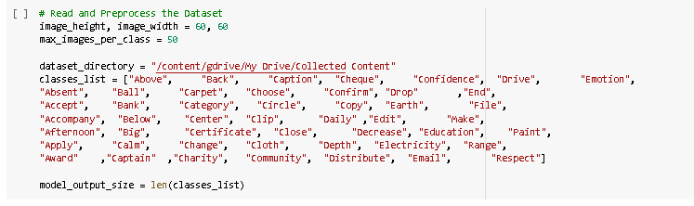

1. Resizing and normalizing the dataset

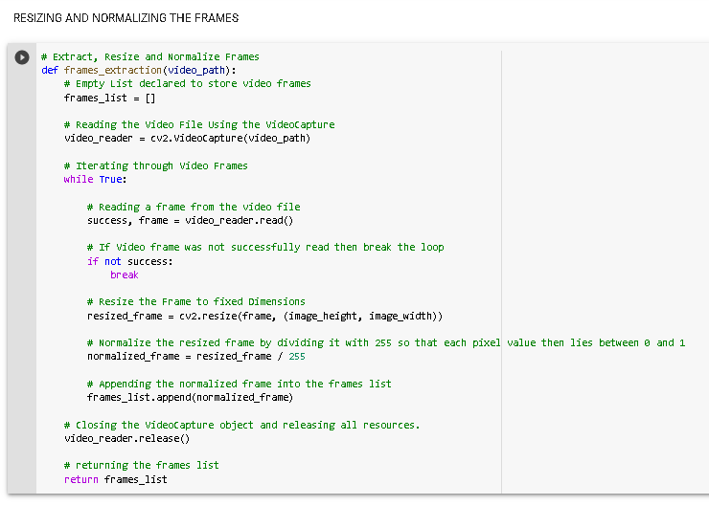

1. Creating dataset

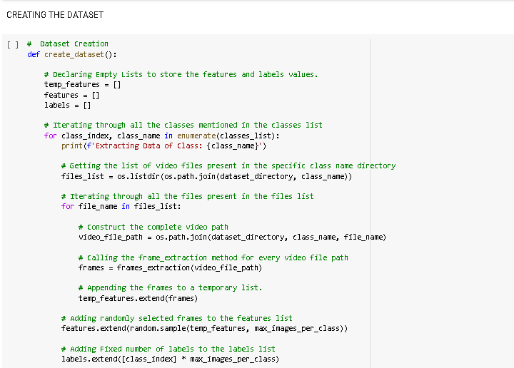

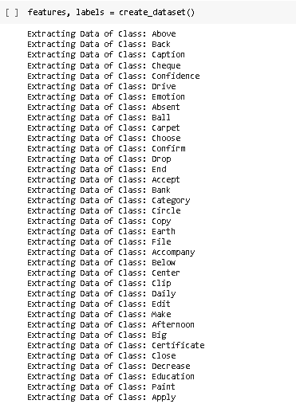

1. Splitting into training and test sets

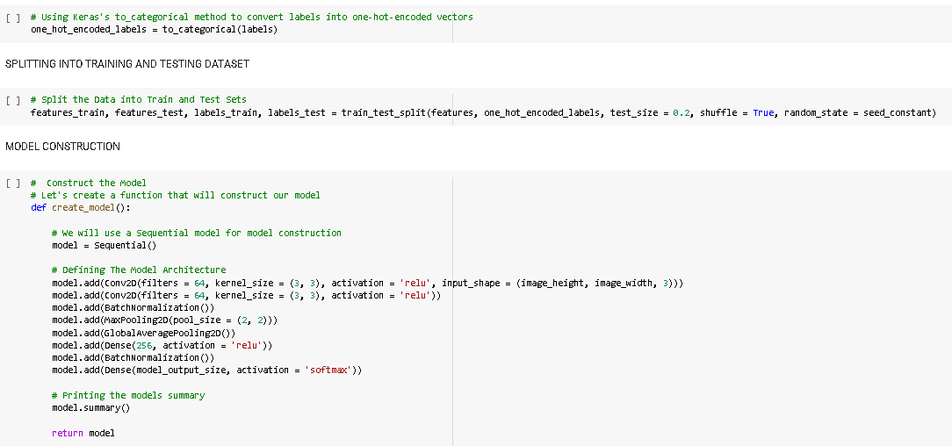

1. Creating model

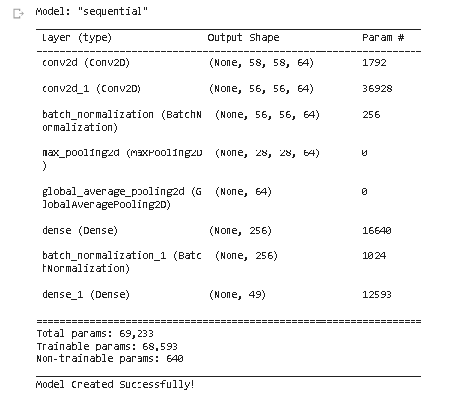

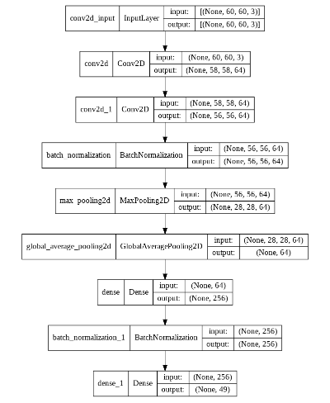

1. Training model

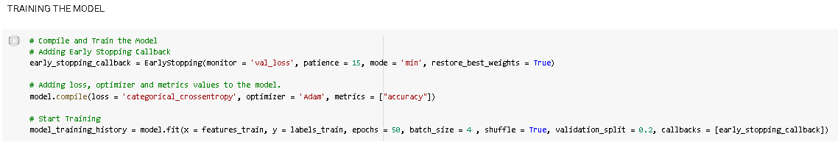

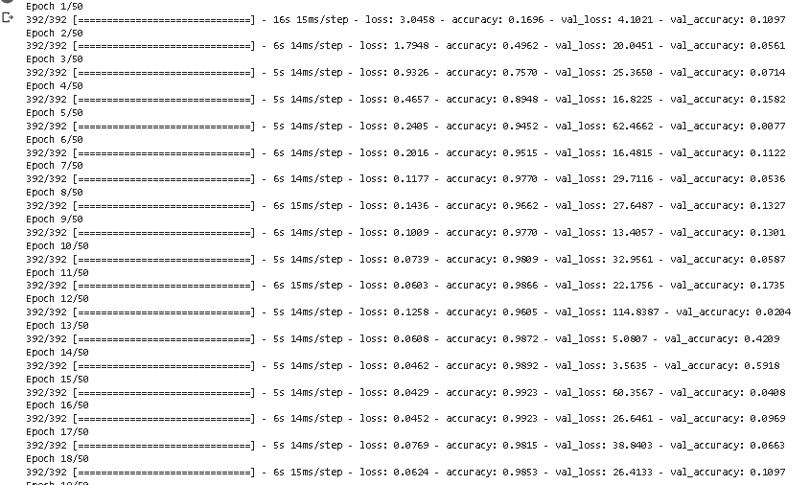

1. Getting model accuracy
2. Saving the model

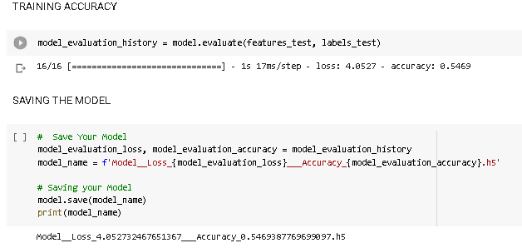

1. Plotting the loss and accuracy curves

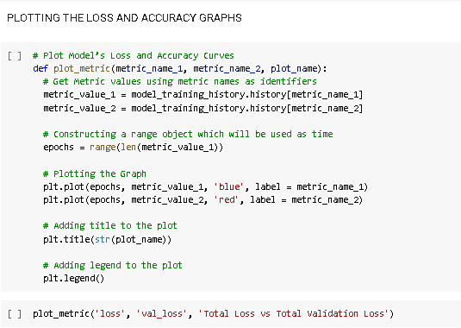

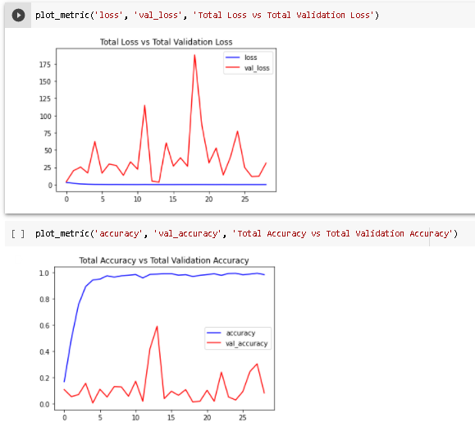

1. Making predictions

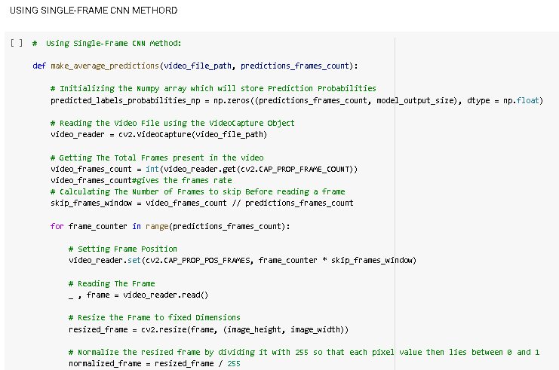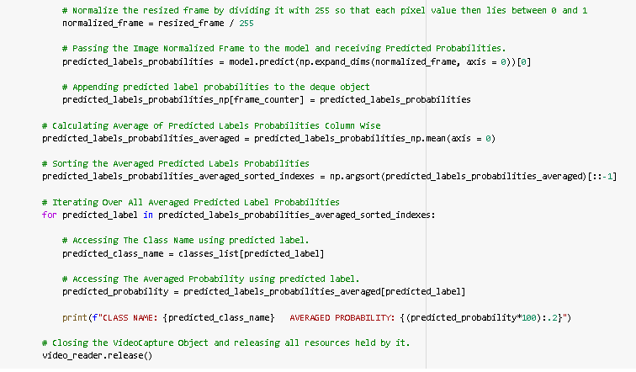

1. Results

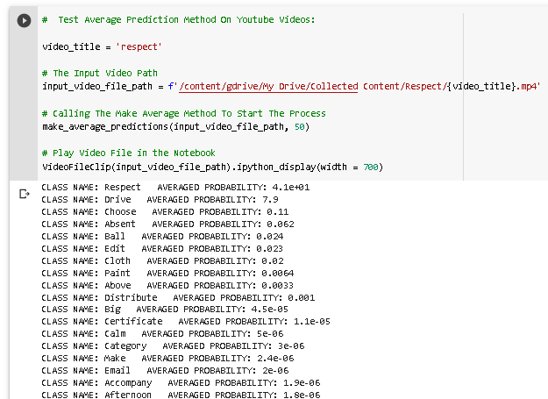

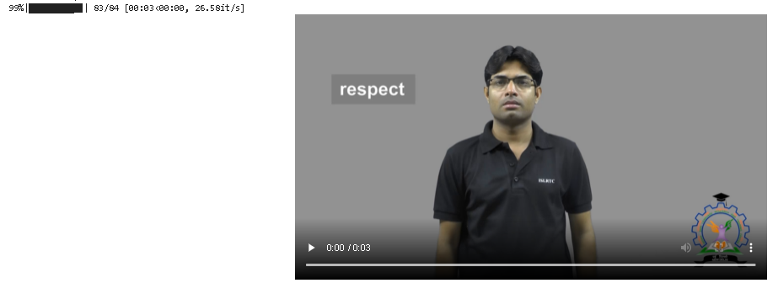

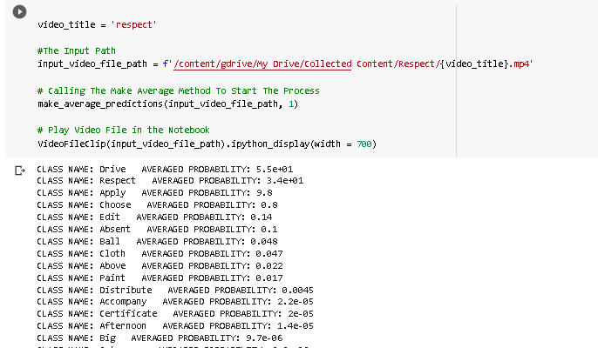

# 10. CONCLUSION

The model we made achieved an accuracy of 55.7% accuracy we need to apply different model of deep learning to get better accuracy and better predictions.

We need to increase the size of dataset also as each video is of 2-3-4 seconds only.

# 11. BIBLIOGRAPHY

1. Ekbote, Juhi, and Mahasweta Joshi. "Indian sign language recognition using ANN and SVM classifiers." In 2017 International conference on innovations in information, embedded and communication systems (ICIIECS), pp. 1-5. IEEE, 2017.
2. Rokade, Yogeshwar I., and Prashant M. Jadav. "Indian sign language recognition system." International Journal of engineering and Technology 9, no. 3 (2017): 189-196.
3. Hore, Sirshendu, Sankhadeep Chatterjee, V. Santhi, Nilanjan Dey, Amira S. Ashour, Valentina Emilia Balas, and Fuqian Shi. "Indian sign language recognition using optimized neural networks." In Information technology and intelligent transportation systems, pp. 553-563. Springer, Cham, 2017.
4. Rao, G. Ananth, and P. V. V. Kishore. "Selfie video based continuous Indian sign language recognition system." Ain Shams Engineering Journal 9, no. 4 (2018): 1929-1939.
5. Rao, G. Anantha, K. Syamala, P. V. V. Kishore, and A. S. C. S. Sastry. "Deep convolutional neural networks for sign language recognition." In 2018 Conference on Signal Processing And Communication Engineering Systems (SPACES), pp. 194-197. IEEE, 2018.
6. Sajanraj, T. D., and M. V. Beena. "Indian sign language numeral recognition using region of interest convolutional neural network." In 2018 Second International Conference on Inventive Communication and Computational Technologies (ICICCT), pp. 636-640. IEEE, 2018.